Development of a Middleware to support adaptive selection of heterogeneous networks based on QoS and performance criteria
Scope:
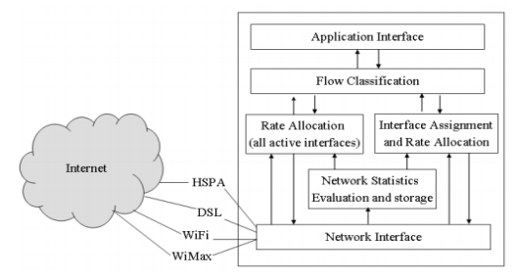
The scope of the diploma thesis involves the design and development of a middleware to facilitate various types of files exchange from a folder or DB over heterogeneous fixed and mobile networks towards a remote location. The focus is given on implementing a certain logic that considers QoS and performance criteria of the utilised networks.
Within the diploma thesis there will be capturing of the standardised QoS and performance requirements of various mobile and wired technologies such as: GPRS, UMTS, HSPA, LTE, SATCOM, TETRA, Wi-Fi, WiMAX, ADSL and VDSL. The requirements shall consider various paradigms of underlying access and transport networks. For each technology, simulations will be performed (OPNET, NS-2, NS-3) considering a simple architecture with minimum nodes (e.g. 2 or 3) under best, medium and worst case scenarios to conclude with QoS and performance thresholds that allow uncorrupted file exchange.
Figure 1-Indicative Functional Architecture
Based on the results above, middleware logic will be developed and implemented on a virtual machine capable of receiving in parallel multiple inputs of network behavior (i.e. simulation above) and assign the optimum access path for files of variable size to be exchanged from source to destination. A non-exhaustive list of QoS and performance criteria follows:
- Throughput-The rate at which the packets go through the network. Maximum rate is always preferred.
- Delay-This is the time which a packet takes to travel from one end to the other. Minimum delay is always preferred.
- Packet Loss Rate-The rate at which a packet is lost. This should also be as minimum as possible.
- Packet Error Rate-This is the errors which are present in a packet due to corrupted bits. This should be as minimum as possible
- Reliability-The availability of a connection. (Links going up/down).
Required:

- Mobile Communications and Networks, Multimedia Services
- Java, C++

The successful completion of the below courses will be considered an asset:

ΚΟΡΜΟΥ: Προγραμματιστικές Τεχνικές , Εισαγωγή στην Επιστήμη των Υπολογιστών
ΡΟΗ Υ: ΥΠΟΛΟΓΙΣΤΙΚΑ ΣΥΣΤΗΜΑΤΑ - Τεχνολογία Πολυμέσων, Τεχνολογία και Ανάλυση Εικόνων και Βίντεο
ΡΟΗ Λ: ΛΟΓΙΣΜΙΚΟ Η/Υ - Γλώσσες Προγραμματισμού Ι , Γλώσσες Προγραμματισμού ΙΙ ,
ΡΟΗ Δ: ΕΠΙΚΟΙΝΩΝΙΕΣ ΚΑΙ ΔΙΚΤΥΑ ΥΠΟΛΟΓΙΣΤΩΝ - Δίκτυα Επικοινωνιών, Δίκτυα Υπολογιστών, Ψηφιακή Τηλεόραση και Επικοινωνίες Πολυμέσων, Δίκτυα Κινητών και Προσωπικών Επικοινωνιών, Διαδίκτυο και Εφαρμογές, Εξομοίωση Συστημάτων Επικοινωνιών, Δίκτυα Ευρείας Ζώνης
ΡΟΗ Τ: ΚΥΜΑΤΑ ΚΑΙ ΤΗΛΕΠΙΚΟΙΝΩΝΙΕΣ - Συστήματα Κινητών Τηλεπικοινωνιών, Δορυφορικές Επικοινωνίες
Supervisors:

Νικόλαος Ουζούνογλου nuzu@cc.ece.ntua.gr
Άγγελος Αμδίτης angelos@esd.ece.ntua.gr

Further info: Αθανασία Τσέρτου atsertou@iccs.gr, Ευάγγελος Σδόγγος esdongos@iccs.gr

